A PROJECT REPORT
ON
SECURING DATA WITH BLOCKCHAIN AND AI
USING PYTHON
Submitted in partial fulfillment for the Award of Credits To
IV-II FOR PROJECT WORK

IN BACHELOR OF TECHNOLOGY

IN
COMPUTER SCIENCE AND ENGINEERING(CYBER SECURITY)

Submitted By:

CHITTURI SAI GANESH KUMAR [20BJ1A4603]
KAGITHA MANOHAR [20BJ1A4604]

RAYAPUDI LAHARI [20BJ1A4608]
SHAIK ISMAIL [20BJ1A4611]
Under the esteemed guidance of
SHAIK SUBHANI, M.Tech

Assistant professor
DEPARTMENT OF COMPUTER SCIENCE AND ENGINEERING

ST.MARY’S GROUP OF INSTITUTIONS GUNTUR
(Affiliated to JNTU KAKINADA, Approved by AICTE, NEWDELHI & Accredited by ‘NAAC’)
CHEBROLU (V&M), GUNTUR DIST., ANDHRA PRADESH, INDIA, PIN: 522212,
2020-2024

ST.MARY’S GROUP OF INSTITUTIONS GUNTUR
(Affiliated to JNTU Kakinada, Approved by AICTE, NEW DELHI & Accredited by ‘NAAC’)
CHEBROLU (V&M), GUNTUR DIST., ANDHRA PRADESH, INDIA, PIN: 522212

DEPARTMENT OF COMPUTER SCIENCE AND ENGINEERING(CYBER SECURITY)


CERTIFICATE

This is to certify that the project report entitled “SECURING DATA WITH BLOCK CHAIN AND AI” is the bonafied project work carried out by CHITTURI SAI GANESH KUMAR [20BJ1A4603], KAGITHA MANOHAR [20BJ1A4604], RAYAPUDI LAHARI [20BJ1A4608], SHAIK ISMAIL [20BJ1A4611] during the academic year 2023-2024, in partial fulfillment of the requirements to the award of the Credits in IV-II of Bachelor of Technology In Computer Science and Engineering from St. Mary’s Group Of Institutions Guntur of Jawaharlal Nehru Technological University, Kakinada.

PROJECT GUIDE  SK.SUBHANI M.Tech  Assistant professor | HEAD OF THE DEPARTMENT  Dr. S S N ANJANEYULU M.Tech, Ph.D  Associate professor

EXTERNAL EXAMINER

ACKNOWLEDGEMENT

On the occasion of presenting the dissertation, We would like to thank the Almighty for providing strength and power by his enormous blessings to overcome all the hurdles and hindrances during this project work.
First & Foremost, We would like to express my sincere gratitude to our guide SHAIK SUBHANI, Assistant professor, Department of Computer Science And Engineering, St. Mary’s Group of Institutions Guntur, for the continuous support of our B. Tech study and research, for his patience, motivation, enthusiasm, and immense knowledge. His guidance helped me in all the time of research and writing of this thesis. I could not have imagined having a better advisor and mentor for our B. Tech study.
We also thank Chairman Sir Rev. Dr. K.V.K. RAO garu, St. Mary’s Group of Institutions Guntur for providing necessary facilities to carry out this research work.
Besides our advisor, we would like to thank Dr. B. PENCHALAIAH, Principal, Dr. S. APPARAO, Director & Dr. S S N ANJANEYULU, Head of The Department, St. Mary’s Group of Institutions Guntur, for their guidance, support, encouragement and valuable suggestions.
We also express my deepest sense of gratitude to all Lab technicians of SMGG. We would like to tthank all the teaching and non-teaching staff of who were very helpful in completion of our project work successfully.
We would extend my heartfelt thanks to our family: our parents for giving birth to me at the first place and supporting me spiritually throughout my life.
We are fortunate to have friends and classmates, who constantly helped me throughout the period, this study was carried out. I extend my hearty gratitude to all those who have directly or indirectly helped me during this research. Thanks to one and all….

ST.MARY’S GROUP OF INSTITUTIONS GUNTUR
(Affiliated to JNTU, KAKINADA, Approved by AICTE, NEWDELHI & Accredited by ‘NAAC’)
CHEBROLU (V&M), GUNTUR DIST., ANDHRA PRADESH, INDIA, PIN: 522212

DEPARTMENT OF COMPUTER SCIENCE AND ENGINEERING(CYBER SECURITY)


DECLARTION

We, CHITTURI SAI GANESH KUMAR [20BJ1A4603], KAGITHA MANOHAR [20BJ1A4604], RAYAPUDI LAHARI [20BJ1A4608], SHAIK ISMAIL [20BJ1A4611] Students of B. Tech, ST.MARY’S GROUP OF INSTITUTIONS GUNTUR, Jawaharlal Nehru Technological University Kakinada, A.P, do hereby Declare that the Project Report Entitled “SECURING DATA WITH BLOCKCHAIN AND AI” is the Genuine Work carried out at ST.MARY’S GROUP OF INSTITUTIONS GUNTUR, under the Guidance of SHAIK SUBHANI, Assistant professor, Department Of Computer Science and Engineering, ST.MARY’S GROUP OF INSTITUTIONS GUNTUR. We declare that the work embodied in the thesis has not been submitted for the award of credits for Degree or Diploma of this or any other University.

CHITTURI SAI GANESH KUMAR [20BJ1A4603]
KAGITHA MANOHAR [20BJ1A4604]
RAYAPUDI LAHARI [20BJ1A4608]
SHAIK ISMAIL [20BJ1A4611]
INDEX

Content Page No
Chapter 1: Introduction 1
1.1 Blockchain 2
1.2 Artificial Intelligence 3
1.3 Rewards 3
Chapter 2: Literature Survey 4
Chapter 3: System Analysis 7
3.1 Existing System 8
3.2 Proposed System 9
3.3 FEASIBILITY STUDY 9
2.3.1 ECONOMICAL FEASIBILITY 10

2.3.2 TECHNICAL FEASIBILITY 10
2.3.3 SOCIAL FEASIBILITY 10
3.4 Hardware Requirements 11
3.5 Software Requirements 11
3.6 Justification of Platform 12
Chapter 4: System Design 16
4.1 Module Division 17
4.2 Data Dictionary 18
4.3 E-R diagrams 18
4.4 UML Diagrams 20

4.4.1 Use case Diagram 21
4.4.2 Sequence Diagram 23
4.4.3 Class Diagram 25
Chapter 5: Implementation 26

5.1 Modules 27

5.2Code 29

Chapter 6: Testing 52

6.1 Testing Approach 53

6.1.1 Unit testing 53

6.1.2 Integration testing 53

6.1.3 Functional test 54

Chapter 7: Results and Discussions 57

Chapter 8: Conclusion 71

Chapter 9: References 73

List of Figures

S. No. | Fig. No. | Fig. Name | Page No.
1 | 3.6.1 | Django Life Cycle. | 12
2 | 3.6.2 | MVT architecture | 13
3 | 4.3.1 | ER Diagram | 20
4 | 4.4.1.1 | Use case Diagram-Patient | 22
5 | 4.4.1.2 | Use case Diagram-Hospital | 23
6 | 4.4.2 | Sequence Diagram | 24
7 | 4.4.3 | Class Diagram | 25
8 | 7.1 | Index page | 58
9 | 7.2 | Patient New Registration | 59
10 | 7.3 | Patient Profile Creation | 60
11 | 7.4 | Hospital1 Login | 61
12 | 7.5 | Hospital1 Welcome page | 62
13 | 7.6 | Access Patient share Data | 63
14 | 7.7 | Patient Data Access | 64
15 | 7.8 | Hospital2 Login | 65
16 | 7.9 | Hospital1 Welcome page | 66
17 | 7.10 | Access Patient share Data | 67
18 | 7.11 | Access Data | 68
18 | 7.12 | Patient Login | 69
19 | 7.13 | Patient ID1 data | 70

List of Tables

S. No. | Table No. | Table Name | Page No.
1 | 4.2.1 | Patients | 18

ABSTRACT
Data is the input for various artificial intelligence (AI) algorithms to mine valuable features, yet data in Internet is scattered everywhere and controlled by different stakeholders who cannot believe in each other, and usage of the data in complex cyberspace is difficult to authorize or to validate. As a result, it is very difficult to enable data sharing in cyberspace for the real big data, as well as a real powerful AI. In this paper, we propose the SecNet, an architecture that can enable secure data storing, computing, and sharing in the large-scale Internet environment, aiming at a more secure cyberspace with real big data and thus enhanced AI with plenty of data source, by integrating three key components:
- Blockchain-based data sharing with ownership guarantee, which enables trusted data sharing in the large-scale environment to form real big data;
- AI-based secure computing platform to produce more intelligent security rules, which helps to construct a more trusted cyberspace;
- Trusted value-exchange mechanism for purchasing security service, providing a way for participants to gain economic rewards when giving out their data or service, which promotes the data sharing and thus achieves better performance of AI. Moreover, we discuss the typical use scenario of SecNet as well as its potentially alternative way to deploy, as well as analyze its effectiveness from the aspect of network security and economic revenue.

Chapter 1
Introduction

- Introduction
In cyber world everything is dependent on data and all Artificial Intelligence algorithms discover knowledge from past data only, for example in online shopping application users review data is very important for new comers to take decision on which product to purchase or not to purchase, we can take many examples like health care to know good hospitals or education institutions etc. Not all cyber data can be made publicly available such as Patient Health Data which contains patient disease details and contact information and if such data available publicly then there is no security for that patient data.
Now a days all service providers such as online social networks or cloud storage will store some type of user’s data and they can sale that data to other organization for their own benefits and user has no control on his data as that data is saved on third party servers.
To overcome from above issue author has describe concept called Private Data Centers (PDC) with Blockchain and AI technique to provide security to user’s data. In this technique 3 functions will work which describe below

  - Blockchain: Blockchain-based data sharing with ownership guarantee, which enables trusted data sharing in the large-scale environment to form real big data. In this technique users can define access control which means which user has permission to access data and which user cannot access data and Blockchain object will be generate on that access data and allow only those users to access data which has permissions. In Blockchain object user will add/subscribe share data and give permission.
  - Artificial Intelligence: AI-based secure computing platform to produce more intelligent security rules, which helps to construct more trusted cyberspace. AI work similar to human brain and responsible to execute logic to check whether requesting user has permission to access shared data. If access is available then AI allow Blockchain to display share data otherwise ignore request.

  - Rewards: In this technique all users who are sharing the data will earn rewards point upon any user access his data trusted value-exchange mechanism for purchasing security service, providing way for participants to gain economic rewards when giving out their data or service, which promotes the data sharing and thus achieves better performance of AI.
To implement this project author has taken medical data sharing example and I am also using same concept to build this project.

Chapter 2
Literature Survey

LITERATURE SURVEY
Data security is among key concerns of any network archi tectures, and is the base for AI algorithms to improve due to its requirement for huge amount of data from as much as possible places in Internet. Meanwhile, with a more powerful AI, data security can be further protected at a higher level Securing Data With Blockchain and AI as an enhanced AI can figure out advanced and complicated threats more easily than normal AI.
To enhance the security of data in CPS(Cyber Physical Systems), numbers of efforts are conducted. The work in presents an archi tecture named Amber to enable decoupling data from the web applications, which gives control ability to web users over their personal data, as well as provides a powerful web-wide query function to search personal data. To extend the decoupling mechanism of data and applications from only web services to all kinds of applications, the research group from the Media Lab in Massachusetts Institute of Technology designs the openPDS(Personal Data Store) , acting as a secured virtual space for users to collect, store and manage their data, separating all kinds of applications from operating on data directly. In addition, openPDS introduces a new service paradigm named SafeAnswer, to dynamically protect data privacy by reducing the dimensions of personal data.
Besides, the emerging blockchain technology provides an efficient and effect way to guarantee the security of data in CPS, by providing tamper-proof and traceable recording features as well as incentive mechanisms. The authors in develop the OriginChain system to realize the transparency and tamper-proof features of the metadata when the supply chain traces products. OriginChain enables all related par ties to obtain the same trusted data and adapt to dynamic environment and regulations. The authors in propose a blockchain-based MeDShare system to effectively manage and protect medical records, as well as share medical data among cloud repositories, with guarantees on data prove nance, auditing and controlling. The work in overviews the background of blockchain and Intrusion Detection Sys tem (IDS) in details, and discusses how to apply blockchain technologies to IDS, as well as gives reasonable guesses about possible hidden dangers in this direction. Besides, the work in designs a blockchain-based incentive mechanism for crowdsensing applications, with privacy preserving and data security guaranteeing.
Furthermore, AI is also a promising way to enhance data security in CPS, since it can deeply analyze huge amount of data, learn hidden patterns and then make accurate pre dictions, with the help of availability of enormous data and increased computational power. The work in has made a detailed overview about the use of AI for big data as well as the use of big data for AI, and also put forward some development directions including how to improve the data security by AI. The work in highlights AI can gain better performance if provided huge amount of data to achieve a better base model, and appeals to develop more efforts for building larger valuable datasets, to empower the AI for better security of data. Furthermore, the work in overviews and presents a comprehensive survey on AI methods for cyber security. In addition, the work in aims at creating a market where participants can exchange machine learning modes for rewards, making AI more practical and accessible to everyone, and thus providing more AI solutions for better security of data.
All these ideas and solutions above propose to protect data security, by designing a new service paradigm supporting the decoupling of data and application, or by designing a specific blockchain to meet demands of certain applications, or by integrating AI algorithms as a functional component to ana lyze data security. However, none of them treats the problem of data security from the view of architecture. To fill this gap, SecNet tries to construct a common and general networking architecture by combining the power of AI and blockchain together at a large scale, which can support dynamic update of all these functional component separately at any time as needed, to efficiently and effectively improve the data secu rity for all applications.
It is worth noting that SecNet is different from HyperNet. For instance, firstly, AI in HyperNet mainly acts as the virtual personal assistant to protect privacy of a single PDC user while AI in SecNet is also in charge of generating artificial data for training more robust security rules, which can be used to enhance AI again. Secondly, how to securely sharing security rules with the help of a detailed on-chain smart contract is given in SecNet, yet HyperNet lacks. In addition, SecNet aims at achieving a more secure cyberspace by sharing not only user data but also security rules produced by AI, while HyperNet only aims at securely sharing user data. Last but not least, PDC is only one of the data storing solutions for SecNet, yet is the only solution for HyperNet.

Chapter 3
System Analysis

3.1 Existing System
- In existing system data protection mechanisms such as encryption was failed in securing the data from the attacker.
- It does not verify whether the user was authorized or not.
3.2 Proposed System
- The proposed system enables Private Data Centers (PDC) with Blockchain and AI technique to provide security to user’s data.
- Blockchain-based data sharing with ownership guarantee, which enables trusted data sharing and generates hash code (unique).
3.3 FEASIBILITY STUDY
The feasibility of the project is analyzed in this phase and business proposal is put forth with a very general plan for the project and some cost estimates. During system analysis the feasibility study of the proposed system is to be carried out. This is to ensure that the proposed system is not a burden to the company. For feasibility analysis, some understanding of the major requirements for the system is essential.
Three key considerations involved in the feasibility analysis are,
- ECONOMICAL FEASIBILITY
- TECHNICAL FEASIBILITY
- SOCIAL FEASIBILITY
3.3.1 ECONOMICAL FEASIBILITY
This study is carried out to check the economic impact that the system will have on the organization. The amount of fund that the company can pour into the research and development of the system is limited. The expenditures must be justified. Thus, the developed system as well within the budget and this was achieved because most of the technologies used are freely available. Only the customized products had to be purchased.

3.3.2 TECHNICAL FEASIBILITY
This study is carried out to check the technical feasibility, that is, the technical requirements of the system. Any system developed must not have a high demand on the available technical resources. This will lead to high demands on the available technical resources. This will lead to high demands being placed on the client. The developed system must have a modest requirement, as only minimal or null changes are required for implementing this system.
3.3.3 SOCIAL FEASIBILITY
The aspect of study is to check the level of acceptance of the system by the user. This includes the process of training the user to use the system efficiently. The user must not feel threatened by the system, instead must accept it as a necessity. The level of acceptance by the users solely depends on the methods that are employed to educate the user about the system and to make him familiar with it. His level of confidence must be raised so that he is also able to make some constructive criticism, which is welcomed, as he is the final user of the system.

3.4 Hardware Requirements

Developing Time Requirements
- Intel ® Core i3 CPU 3.0 GHz or above
- 4GMRAM
- 500GB Hard Disk Drive (HDD) + 24GB Solid State Drive(SSD)
- Monitor
Runtime Requirements
  - Processor: Intel Atom® Processor Z2520 1.2 GHz, or faster processor
  - Storage: Between 850 MB and 1.2 GB, depending on the language version
  - RAM: Minimum of 512 MB, 2 GB is recommended
  - Hard Disk: 2GB of available hard-disk space for installation; extra free space is required during installation.

3.5 Software Requirements
- IDE: PyCharm
- Front End: Html, CSS, JS
- Back End: MySQL Server
- Operating System: Window 7/Window 10
- Programming Language: Python
3.6 Justification of Platform
PYTHON
Python is a general-purpose interpreted, interactive, object-oriented, and high-level programming language. An interpreted language, Python has a design philosophy that emphasizes code readability (notably using whitespace indentation to delimit code blocks rather than curly brackets or keywords), and a syntax that allows programmers to express concepts in fewer lines of code than might be used in languages such as C++or Java. It provides constructs that enable clear programming on both small and large scales. Python interpreters are available for many operating systems. CPython, the reference implementation of Python, is open-source software and has a community-based development model, as do nearly all its variant implementations. CPython is managed by the non-profit Python Software Foundation. Python features a dynamic type of system and automatic memory management. It supports multiple programming paradigms, including object-oriented, imperative, functional and procedural, and has a large and comprehensive standard library.
Python is a multi-paradigm programming language. Object-oriented programming and structured programming are fully supported, and many of its features support functional programming and aspect-oriented programming (including by Meta programming and meta-objects (magic methods)). Many other paradigms are supported via extensions, including design by contract and logic programming.
Python uses dynamic typing, and a combination of reference counting and a cycle-detecting garbage collector for memory management. It also features dynamic name resolution (late binding), which binds method and variable names during program execution.

DJANGO
Django is a high-level Python Web framework that encourages rapid development and clean, pragmatic design. Built by experienced developers, it takes care of much of the hassle of Web development, so you can focus on writing your app without needing to reinvent the wheel. It is free and open source.
Django's primary goal is to ease the creation of complex, database-driven websites. Django emphasizes reusability and "pluggability" of components, rapid development, and the principle of do not repeat yourself.
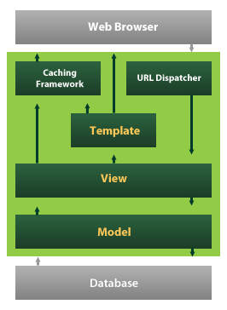
Fig.3.6.1 Django Life Cycle.
Django also provides an optional administrative create, read, update and delete interface that is generated dynamically through introspection and configured via admin models.

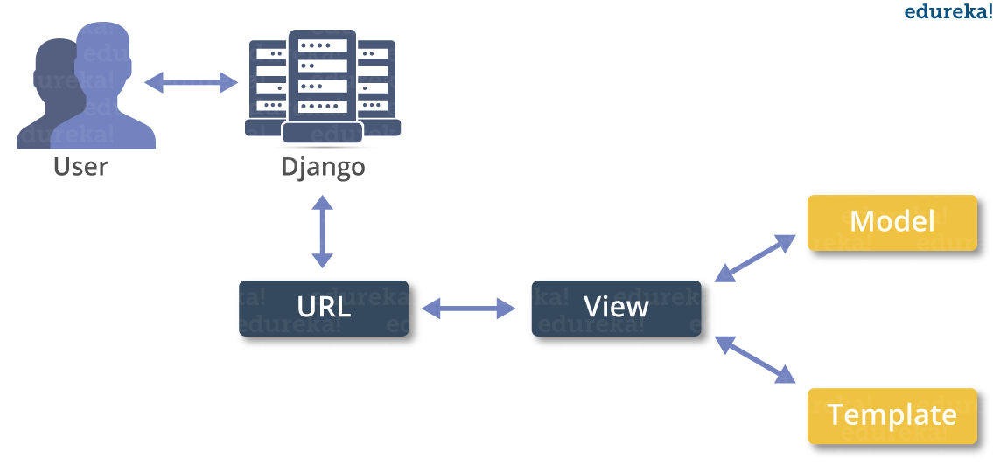
Fig.3.6.2 MVT architecture.

Despite having its own nomenclature, such as naming the callable objects generating the HTTP responses "views", the core Django framework can be seen as MVT architecture. It consists of an object-relational mapper (ORM) that mediates between data models (defined as Python classes) and a relational database ("Model"), a system for processing HTTP requests with a web templating system("View"), and a regular-expression-based URL dispatcher ("Controller").
Also included in the core framework are:
• A lightweight and standalone web server for development and testing
• A form serialization and validation system that can translate between HTML forms and values suitable for storage in the database
• A template system that utilizes the concept of inheritance borrowed from object-oriented programming
• A caching framework that can use any of several cache methods
• Support for middleware classes that can intervene at various stages of request processing and carry out custom functions
• An internal dispatcher system that allows components of an application to communicate events to each other via pre-defined signals.
• An internationalization system, including translations of Django's own components into a variety of languages
• A system for extending the capabilities of the template engine
• An interface to Python's built-in unit test framework

MySQL Database
MySQL is a fast, easy-to-use RDBMS being used for many small and big businesses. MySQL is developed, marketed and supported by MySQL AB, which is a Swedish company. MySQL is becoming so popular because of many good reasons,
- MySQL is released under an open-source license. So, user has nothing to pay to use it.
- MySQL is a very powerful program in its own right. It handles a large subset of the functionality of the most expensive and powerful database packages.
- MySQL uses a standard form of the well-known SQL data language.
- MySQL works on many operating systems and with many languages including PHP, PERL, C, C++, JAVA, Python etc.
- MySQL works very quickly and works well even with large datasets.
- MySQL is very friendly to PHP, the most appreciated language for web development.
MySQL supports large databases, up to 50 million rows or more in a table. The default file size limit for a table is 4GB, but user can increase this (if user’s operating system can handle it) to a theoretical limit of 8 million terabytes (TB).

Chapter 4

System Design

4.1 Module Division
Description of the Modules
- Patients: Patients first create his profile with all disease details and then select desired hospital with whom he wishes to share/subscribe data. While creating profile application will create Blockchain object with allowable permission and it will allow only those hospitals to access data.
- Patient Login: Patient can login to application with his profile id and check total rewards he earned from sharing data.
- Hospital: Hospital1 and Hospital2 are using in this application as two organizations with whom patient can share data. At a time, any hospital can login to application and then enter search string as disease name.

AI algorithm will take input disease string and then perform search operation on all patients to get similar disease patients and then check whether this hospital has permission to access that patient data or not, if hospital has access permission, then it will display those patients records to that hospital.

4.2 Data Dictionary

PATIENTS:

Column | Type | Null
patient_id | Int | No
patient_name | varchar (50) | No
Age | Int | No
problem_desc | varchar (500) | No
profile_date | Date | No
access_data | varchar (200) | No
Gender | varchar (30) | No
contact_no | varchar (12) | No
Address | varchar (100) | No
blockchain_hash | varchar (200) | No
Revenue | double | No

Fig.4.2.1

4.3 E-R diagrams
- A database is a collection of entities or a relation among entities.
- Entity: An entity is an individual object that exists and distinguishes from other individuals.
- Entities have attributes
      - Examples: people have names and addresses.
- Entity Set: An entity set is a set of entities of the same type that share the same properties.
- Attributes: An entity is represented by the set of attributes, i.e. descriptive properties possessed by all members of entity set.
- Types of attributes:
  - Single and Composite attributes
  - Single-valued and multi-valued attributes
  - Derived attributes
- Relationship: A relationship is an association among several entities.
- Relationship Set: A relationship set is a mathematical relation among n>=2 entities, each taken from entity sets.
- Weak Entity: A weak entity is an entity that must defined by a foreign key relationship with another entity as it cannot be uniquely identified by its own attributes alone.
- Primary Key: A minimal super key for each entity set among its super key; the minimal super key is termed as the entity set’s primary key.
- Super Key: A super key is a set of one or more attributes that, taken collectively; allow us to identify uniquely an entity in the entity set.

E-R diagram representation:

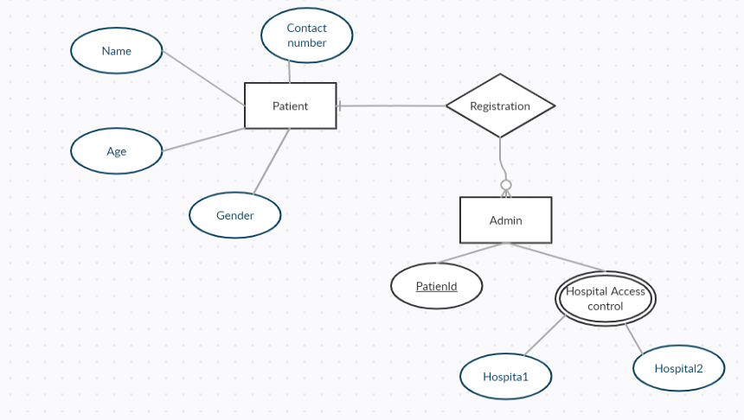
Fig.4.3.1 ER diagram

4.4 UML Diagrams
The Unified Modeling Language (UML) is a standardized visual specification language for object modeling. UML is a general-purpose modeling language that includes a graphical notation used to create an abstract model of a system, referred to as a UML model. The goal is for UML to become a common language for creating models of object-oriented computer software. In its current form UML is comprised of two major components: a Meta- model and a notation. In the future, some form of method or process may also be added to; or associated with, UML. The Unified Modeling Language is a standard language for specifying, Visualization, Constructing and documenting the artifacts of the software system as well as for business modeling and other non-software systems. The UML represents a collection of best engineering practices that proven successful in the modeling of large and complex systems. The UML is a very important part of developing objects-oriented software and the software development process. The UML uses mostly graphical notations to express the design of software projects.

Goals:
The primary goals in the design of the UML are as follows:
      - Provides users a ready-to-use, expensive visual modeling Language so that they can develop and exchange meaningful models.
      - Provide extendibility and specialization mechanisms to extend the core concepts.
      - Be independent of particular programming languages and development process.
      - Provide a formal basis for understanding the modeling language.
      - Encourage the growth of OO tools methods.
      - Support higher level development concepts such as collaborations, frameworks, patterns and components.
      - Integrate best practices.

4.4.1 Use case Diagram
A use case diagram is the Unified Modeling Language (UML) is a type of behavioral diagram defined is and created from a Use-case analysis. A use case diagram shows a set of use cases and actors and their relationships. Users apply the use case diagram to illustrate the static and use case view of a system. Use case diagram are especially important in organizing and modeling the behaviors of a system.
Use case For Patient
Fig.4.4.1.1 Use case for patient

Use case for Hospital

Fig.4.4.1.2 Use case for Hospital.

4.4.2 Sequence Diagram
A sequence diagram in a unified modeling language is kind of interaction that shows how processes operate with one another in what order. It is a construct of message sequence chart. Sequence diagrams are sometimes called as event diagrams or event scenarios, and timing diagrams.

Sequence Diagram
Fig.4.4.2 Sequence Diagram

4.4.3 Class Diagram
Class diagram is a static diagram. It represents the static view of an application. Class diagram is not only used for visualizing, describing, and documenting different aspects of a system but also for constructing executable code of the software application.
Class diagram describes the attributes and operations of a class and also the constraints imposed on the system. The class diagrams are widely used in the modeling of object-oriented systems because they are the only UML diagrams, which can be mapped directly with object-oriented languages.
Class diagram shows a collection of classes, interfaces, associations, collaborations, and constraints. It is also known as a structural diagram.
Class Diagram

Fig.4.4.3 Class Diagram

Chapter 5
Implementation

5.1Modules
To implement this project author has taken medical data sharing example and I am doing same concept to build this project.

Modules Information:
This project consists of two modules
- Patients:
Patients first create his profile with all disease details and then select desired hospital with whom he wishes to share or subscribe data. While creating profile application will create blockchain object with allowable permission and it will allow only those hospitals to access the data.
Patient Login:
Patient can login to application with his profile id and check total rewards he earned from sharing data.
- Hospital:
Hospital 1 and Hospital 2 are using in this application as two organizations with whom patient can share data. At a time any hospital can login to application and then enter search string as disease name.
AI algorithm will take input disease string and then perform search operation on all the patients to get similar disease patients and then check whether this hospital has permission to access that patient data or not, if hospital has access permission then it will display those patients records to that hospital.

Below is the code example to create blockchain object with patient data.
blockchain = Blockchain()

5.2Code

Index.html:
{% load static %}
<html>
<head>
<title>Securing Data With Blockchain and AI</title>
<meta http-equiv="content-type" content="text/html; charset=utf-8" />
<link href="{% static 'style.css' %}" rel="stylesheet" type="text/css" />
</head>
<body>
<div class="main">
<div class="main_resize">
<div class="header">
<div class="logo">
<h1><span>Securing Data With Blockchain and AI</span><small></small></h1>
</div>
</div>
<div class="content">
<div class="content_bg">
<div class="menu_nav">
<ul>
<ul>
<li><a href="{% url 'index' %}">Home</a></li>
<li><a href="{% url 'Hospital' %}">Hospital</a></li>
<li><a href="{% url 'Patient' %}">Patients Login</a></li>
<li><a href="{% url 'CreateProfile' %}">New Patient Register Here</a></li>
</ul>
</ul>
</div>
<div class="hbg"><imgsrc="{% static 'images/header_images.jpg' %}" width="915" height="286" alt="" /></div>

{{ data }}

<p align="justify"><font size="3" style="font-family: Comic Sans MS" color="black">Abstract-Data is the input for various articial intelligence (AI) algorithms to mine valuable features, yet
data in Internet is scattered everywhere and controlled by different stakeholders who cannot believe in each
other, and usage of the data in complex cyberspace is difcult to authorize or to validate. As a result, it is very
difcult to enable data sharing in cyberspace for the real big data, as well as a real powerful AI. </p>
<p align="justify"><font size="3" style="font-family: Comic Sans MS" color="black">
In this paper,
we propose the SecNet, an architecture that can enable secure data storing, computing, and sharing in the
large-scale Internet environment, aiming at a more secure cyberspace with real big data and thus enhanced
AI with plenty of data source, by integrating three key components:</p>
<p align="justify"><font size="3" style="font-family: Comic Sans MS" color="black">

1) blockchain-based data sharing with
ownership guarantee, which enables trusted data sharing in the large-scale environment to form real big data. <br/>

2) AI-based secure computing platform to produce more intelligent security rules, which helps to construct
a more trusted cyberspace. <br/>

3) trusted value-exchange mechanism for purchasing security service, providing
a way for participants to gain economic rewards when giving out their data or service, which promotes the
data sharing and thus achieves better performance of AI. Moreover, we discuss the typical use scenario of
SecNet as well as its potentially alternative way to deploy, as well as analyze its effectiveness from the aspect
of network security and economic revenue. </p>

</body>
</html>

Hospital.html:
{% load static %}
<html>
<head>
<title>Securing Data With Blockchain and AI</title>
<meta http-equiv="content-type" content="text/html; charset=utf-8" />
<link href="{% static 'style.css' %}" rel="stylesheet" type="text/css" />
<script language="javascript">
function validate(formObj)
{
if(formObj.t1.value.length==0)
{
alert("Please Enter Username");
formObj.t1.focus();
return false;
}
if(formObj.t2.value.length==0)
{
alert("Please Enter Password");
formObj.t2.focus();
return false;
}
formObj.actionUpdateData.value="update";
return true;
}
</script>
<script language="javascript" type="text/javascript" src="datetimepicker.js">
</script>
</head>
<body>
<div class="main">
<div class="main_resize">
<div class="header">
<div class="logo">
<h1><span>Securing Data With Blockchain and AI</span><small></small></h1>
</div>
</div>
<div class="content">
<div class="content_bg">
<div class="menu_nav">
<ul>
<li><a href="{% url 'index' %}">Home</a></li>
<li><a href="{% url 'Hospital' %}">Hospital</a></li>
<li><a href="{% url 'Patient' %}">Patients Login</a></li>
<li><a href="{% url 'CreateProfile' %}">New Patient Register Here</a></li>
</ul>
</div>
<div class="hbg"><imgsrc="{% static 'images/header_images.jpg' %}" width="915" height="286" alt="" /></div>
<center>
<form name="f1" method="post" action={% url 'HospitalLogin' %} onsubmit="return validate(this);">
{% csrf_token%}<br/>
<h2><b>Hospital Login Screen</b></h2>

<font size="" color="red"><center>{{ data }}</center></font>

<table align="center" width="30%" >
<tr><td><b>Username</b></td>
<td><input type="text" name="t1" style="font-family: Comic Sans MS" size="30"></td></tr>

<tr><td><b>Password</b></td><td><input name="t2" type="password" size="30"></td></tr>

<tr><td></td><td><input type="submit" value="Login"></td>
</table>
</div>

</div>

</body>
</html>

HospitalScreen.html:
{% load static %}
<html>
<head>
<title>Securing Data With Blockchain and AI</title>
<meta http-equiv="content-type" content="text/html; charset=utf-8" />
<link href="{% static 'style.css' %}" rel="stylesheet" type="text/css" />
</head>
<body>
<div class="main">
<div class="main_resize">
<div class="header">
<div class="logo">
<h1><span>Securing Data With Blockchain and AI</span><small></small></h1>
</div>
</div>
<div class="content">
<div class="content_bg">
<div class="menu_nav">
<ul>
<ul>
<li><a href="{% url 'AccessData' %}">Access Patient Share Data</a></li>
<li><a href="{% url 'index' %}">Logout</a></li>
</ul>
</ul>
</div>
<div class="hbg"><imgsrc="{% static 'images/header_images.jpg' %}" width="915" height="286" alt="" /></div>

<font size="3" color="red"><center>{{ data }}</center></font></body>
</html>

AccessData.html:
{% load static %}
<html>
<head>
<title>Securing Data With Blockchain and AI</title>
<meta http-equiv="content-type" content="text/html; charset=utf-8" />
<link href="{% static 'style.css' %}" rel="stylesheet" type="text/css" />
<script language="javascript">
function validate(formObj)
{
if(formObj.t1.value.length==0)
{
alert("Please Enter search data");
formObj.t1.focus();
return false;
}
formObj.actionUpdateData.value="update";
return true;
}
</script>
<script language="javascript" type="text/javascript" src="datetimepicker.js">
</script>
</head>
<body>
<div class="main">
<div class="main_resize">
<div class="header">
<div class="logo">
<h1><span>Securing Data With Blockchain and AI</span><small></small></h1>
</div>
</div>
<div class="content">
<div class="content_bg">
<div class="menu_nav">
<ul>
<li><a href="{% url 'AccessData' %}">Access Patient Share Data</a></li>
<li><a href="{% url 'index' %}">Logout</a></li>
</ul>
</div>
<div class="hbg"><imgsrc="{% static 'images/header_images.jpg' %}" width="915" height="286" alt="" /></div>
<center>
<form name="f1" method="post" action={% url 'PatientDataAccess' %} onsubmit="return validate(this);">
{% csrf_token%}<br/>
<h2><b>Patient Share Data Access Screen</b></h2>

<font size="" color="red"><center>{{ data }}</center></font>

<table align="center" width="30%" >
<tr><td><b>AI&nbsp;Search&nbsp;String</b></td>
<td><input type="text" name="t1" style="font-family: Comic Sans MS" size="30"></td></tr>

<tr><td></td><td><input type="submit" value="Access Data"></td>
</table>
</div>
</div>

</body>
</html>

ViewAccessData.html:
{% load static %}
<html>
<head>
<title>Securing Data With Blockchain and AI</title>
<meta http-equiv="content-type" content="text/html; charset=utf-8" />
<link href="{% static 'style.css' %}" rel="stylesheet" type="text/css" />
<script language="javascript">
function validate(formObj)
{
if(formObj.t1.value.length==0)
{
alert("Please Enter search data");
formObj.t1.focus();
return false;
}
formObj.actionUpdateData.value="update";
return true;
}
</script>
<script language="javascript" type="text/javascript" src="datetimepicker.js">
</script>
</head>
<body>
<div class="main">
<div class="main_resize">
<div class="header">
<div class="logo">
<h1><span>Securing Data With Blockchain and AI</span><small></small></h1>
</div>
</div>
<div class="content">
<div class="content_bg">
<div class="menu_nav">
<ul>
<li><a href="{% url 'AccessData' %}">Access Patient Share Data</a></li>
<li><a href="{% url 'index' %}">Logout</a></li>
</ul>
</div>

<div class="hbg"><imgsrc="{% static 'images/header_images.jpg' %}" width="915" height="286" alt="" /></div>
<center>

<br/>
{{ data|safe }}

</body>
</html>

CreateProfile.html:
{% load static %}
<html>
<head>
<title>Securing Data With Blockchain and AI</title>
<meta http-equiv="content-type" content="text/html; charset=utf-8" />
<link href="{% static 'style.css' %}" rel="stylesheet" type="text/css" />
<script language="javascript">
function validate(formObj)
{
if(formObj.t1.value.length==0)
{
alert("Please Enter patient name");
formObj.t1.focus();
return false;
}
if(formObj.t2.value.length==0)
{
alert("Please Enter Age");
formObj.t2.focus();
return false;
}
if(isNaN(formObj.t2.value)){
alert("Age must be numeric");
formObj.t2.focus();
return false;
}
if(formObj.t3.value.length==0)
{
alert("Please Enter Problem Description");
formObj.t3.focus();
return false;
}

if(formObj.t6.value.length==0)
{
alert("Please Enter Contact No");
formObj.t6.focus();
return false;
}
if(isNaN(formObj.t6.value)){
alert("Contact No must be numeric");
formObj.t6.focus();
return false;
}
if(formObj.t7.value.length==0)
{
alert("Please Enter Address");
formObj.t7.focus();
return false;
}
formObj.actionUpdateData.value="update";
return true;
}
</script>
<script language="javascript" type="text/javascript" src="datetimepicker.js">
</script>
</head>
<body>
<div class="main">
<div class="main_resize">
<div class="header">
<div class="logo">
<h1><span>Securing Data With Blockchain and AI</span><small></small></h1>
</div>
</div>
<div class="content">
<div class="content_bg">
<div class="menu_nav">
<ul>
<li><a href="{% url 'index' %}">Home</a></li>
<li><a href="{% url 'Hospital' %}">Hospital</a></li>
<li><a href="{% url 'Patient' %}">Patients Login</a></li>
<li><a href="{% url 'CreateProfile' %}">New Patient Register Here</a></li>
</ul>
</div>
<div class="hbg"><imgsrc="{% static 'images/header_images.jpg' %}" width="915" height="286" alt="" /></div>
<center>
<form name="f1" method="post" action={% url 'CreateProfileData' %} onsubmit="return validate(this);">
{% csrf_token%}<br/>
<h2><b>Patients Profile Creation Screen</b></h2>

<font size="" color="red"><center>{{ data }}</center></font>

<table align="center" width="30%" >
<tr><td><b>Patient&nbsp;Name</b></td>
<td><input type="text" name="t1" style="font-family: Comic Sans MS" size="30"></td></tr>

<tr><td><b>Age</b></td><td><input name="t2" type="Text" size="10"></td></tr>

<tr><td><b>Problem&nbsp;Desc</b></td>
<td><textarea name="t3" rows="10" cols="60"></textarea></td></tr>

<tr><td><b>Access Control</b></td><td><select name="t4" multiple>
<option value="Hospital1">Hospital 1</option>
<option value="Hospital2">Hospital 2</option>
</select>
</td></tr>

<tr><td><b>Gender</b></td><td><select name="t5" style="font-family: Comic Sans MS">
<option value="Male">Male</option>
<option value="Female">Female</option>
</select>
</td></tr>

<tr><td><b>Contact&nbsp;No</b></td><td><input type="text" name="t6" style="font-family: Comic Sans MS" size=20/></td></tr>

<tr><td><b>address</b></td><td><textarea name="t7" style="font-family: Comic Sans MS" rows="6" cols="30"></textarea></td></tr>
<tr><td></td><td><input type="submit" value="Create"></td>
</table>
</div>

</div>
</body>
</html>

Patient.html:
{% load static %}
<html>
<head>
<title>Securing Data With Blockchain and AI</title>
<meta http-equiv="content-type" content="text/html; charset=utf-8" />
<link href="{% static 'style.css' %}" rel="stylesheet" type="text/css" />
<script language="javascript">
function validate(formObj)
{
if(formObj.t1.value.length==0)
{
alert("Please Enter Patient ID");
formObj.t1.focus();
return false;
}

formObj.actionUpdateData.value="update";
return true;
}
</script>
<script language="javascript" type="text/javascript" src="datetimepicker.js">
</script>
</head>
<body>
<div class="main">
<div class="main_resize">
<div class="header">
<div class="logo">
<h1><span>Securing Data With Blockchain and AI</span><small></small></h1>
</div>
</div>
<div class="content">
<div class="content_bg">
<div class="menu_nav">
<ul>
<li><a href="{% url 'index' %}">Home</a></li>
<li><a href="{% url 'Hospital' %}">Hospital</a></li>
<li><a href="{% url 'Patient' %}">Patients Login</a></li>
<li><a href="{% url 'CreateProfile' %}">New Patient Register Here</a></li>
</ul>
</div>
<div class="hbg"><imgsrc="{% static 'images/header_images.jpg' %}" width="915" height="286" alt="" /></div>
<center>
<form name="f1" method="post" action={% url 'PatientLogin' %} onsubmit="return validate(this);">
{% csrf_token%}<br/>
<h2><b>Patient Login Screen</b></h2>
<font size="" color="red"><center>{{ data }}</center></font>

<table align="center" width="30%" >
<tr><td><b>Patient&nbsp;ID</b></td>
<td><input type="text" name="t1" style="font-family: Comic Sans MS" size="30"></td></tr>
<tr><td></td><td><input type="submit" value="Login"></td>
</table>
</div>
</div>
</body>
</html>

ViewData.html:
{% load static %}
<html>
<head>
<title>Securing Data With Blockchain and AI</title>
<meta http-equiv="content-type" content="text/html; charset=utf-8" />
<link href="{% static 'style.css' %}" rel="stylesheet" type="text/css" />
<script language="javascript">
function validate(formObj)
{
if(formObj.t1.value.length==0)
{
alert("Please Enter search data");
formObj.t1.focus();
return false;
}
formObj.actionUpdateData.value="update";
return true;
}
</script>
<script language="javascript" type="text/javascript" src="datetimepicker.js">
</script>
</head>
<body>
<div class="main">
<div class="main_resize">
<div class="header">
<div class="logo">
<h1><span>Securing Data With Blockchain and AI</span><small></small></h1>

</div>
</div>
<div class="content">
<div class="content_bg">
<div class="menu_nav">
<ul>

<li><a href="{% url 'index' %}">Logout</a></li>
</ul>
</div>
<div class="hbg"><imgsrc="{% static 'images/header_images.jpg' %}" width="915" height="286" alt="" /></div>
<center>

<br/>
{{ data|safe }}

</body>
</html>

Views.py
from django.shortcuts import render
from django.template import RequestContext
from django.contrib import messages
import pymysql
from django.http import HttpResponse
import datetime
import json
import time
from hashlib import sha256

class Blockchain:
# difficulty of our PoW algorithm
difficulty = 2

def __init__(self):
self.unconfirmed_transactions = []
self.chain = []
self.create_genesis_block()

def create_genesis_block(self):
"""
A function to generate genesis block and appends it to
the chain. The block has index 0, previous_hash as 0, and
a valid hash.
"""
genesis_block = Block(0, [], time.time(), "0")
genesis_block.hash = genesis_block.compute_hash()
self.chain.append(genesis_block)
@property
def last_block(self):
return self.chain[-1]

def add_block(self, block, proof):
"""
A function that adds the block to the chain after verification.
Verification includes:
* Checking if the proof is valid.
* The previous_hash referred in the block and the hash of latest block
in the chain match.
"""
previous_hash = self.last_block.hash

if previous_hash != block.previous_hash:
return False

if not self.is_valid_proof(block, proof):
return False

block.hash = proof
print("main "+str(block.hash))
self.chain.append(block)
return True

def is_valid_proof(self, block, block_hash):
"""
Check if block_hash is valid hash of block and satisfies
the difficulty criteria.
"""
print("compare "+str(block_hash == block.compute_hash())+" "+block.compute_hash()+" "+str(block_hash.startswith('0' * Blockchain.difficulty)))
return (block_hash.startswith('0' * Blockchain.difficulty) and
block_hash == block.compute_hash())

def proof_of_work(self, block):
"""
Function that tries different values of nonce to get a hash
that satisfies our difficulty criteria.
"""
block.nonce = 0

computed_hash = block.compute_hash()
while not computed_hash.startswith('0' * Blockchain.difficulty):
block.nonce += 1
computed_hash = block.compute_hash()

return computed_hash

def add_new_transaction(self, transaction):
self.unconfirmed_transactions.append(transaction)

def mine(self):
"""
This function serves as an interface to add the pending
transactions to the blockchain by adding them to the block
and figuring out Proof of Work.
"""
if not self.unconfirmed_transactions:
return False

last_block = self.last_block

new_block = Block(index=last_block.index + 1,
transactions=self.unconfirmed_transactions,
timestamp=time.time(),
previous_hash=last_block.hash)

proof = self.proof_of_work(new_block)
self.add_block(new_block, proof)

self.unconfirmed_transactions = []
return proof

class Block:
def __init__(self, index, transactions, timestamp, previous_hash):
self.index = index
self.transactions = transactions
self.timestamp = timestamp
self.previous_hash = previous_hash
self.nonce = 0

def compute_hash(self):
"""
A function that return the hash of the block contents.
"""
block_string = json.dumps(self.__dict__, sort_keys=True)
return sha256(block_string.encode()).hexdigest()

def AccessData(request):
if request.method == 'GET':
return render(request, 'AccessData.html', {})

def index(request):
if request.method == 'GET':
return render(request, 'index.html', {})

def CreateProfile(request):
if request.method == 'GET':
return render(request, 'CreateProfile.html', {})

def Hospital(request):
if request.method == 'GET':
return render(request, 'Hospital.html', {})

def Patient(request):
if request.method == 'GET':
return render(request, 'Patient.html', {})

def PatientLogin(request):
if request.method == 'POST':
pid = request.POST.get('t1', False)
strdata = '<table border=1 align=center width=100%><tr><th>Patient ID</th><th>Patient Name</th><th>Age</th><th>Problem Description</th><th>Profile Date</th><th>Access Control</th><th>Gender</th><th>Contact No</th><th>Address</th><th>Block Chain Hashcode</th><th>Revenue</th></th></tr><tr>'
con = pymysql.connect(host='127.0.0.1',port = 3308,user = 'root', password = 'root', database = 'SecuringData',charset='utf8')
with con:
cur = con.cursor()
cur.execute("select * FROM patients")
rows = cur.fetchall()
for row in rows:
if str(row[0]) == pid:
strdata+='<td>'+str(row[0])+'</td><td>'+row[1]+'</td><td>'+str(row[2])+'</td><td>'+str(row[3])+'</td><td>'+str(row[4])+'</td><td>'+row[5]+'</td><td>'+row[6]+'</td><td>'+row[7]+'</td><td>'+row[8]+'</td><td>'+row[9]+'</td><td>'+str(row[10])+'</td></tr><tr>'
context= {'data':strdata}
return render(request, 'ViewData.html', context)

def HospitalLogin(request):
if request.method == 'POST':
username = request.POST.get('t1', False)
password = request.POST.get('t2', False)
file = open('session.txt','w')
file.write(username)
file.close()
if username == 'Hospital1' and password == 'Hospital1' or username == 'Hospital2' and password == 'Hospital2':
context= {'data':'welcome '+username}
return render(request, 'HospitalScreen.html', context)
else:
context= {'data':'login failed'}
return render(request, 'Hospital.html', context)

def updateRevenue(value):
db_connection = pymysql.connect(host='127.0.0.1',port = 3306,user = 'root', password = 'root', database = 'SecuringData',charset='utf8')
db_cursor = db_connection.cursor()
db_cursor.execute("update patients set revenue=revenue+0.5 where patient_id='"+value+"'")
db_connection.commit()

def PatientDataAccess(request):
if request.method == 'POST':
search = request.POST.get('t1', False)
user = ''
with open("session.txt", "r") as file:
for line in file:
user = line.strip('\n')
strdata = '<table border=1 align=center width=100%><tr><th>Patient ID</th><th>Patient Name</th><th>Age</th><th>Problem Description</th><th>Profile Date</th><th>Access Control</th><th>Gender</th><th>Contact No</th></th></tr><tr>'
con = pymysql.connect(host='127.0.0.1',port = 3308,user = 'root', password = 'root', database = 'SecuringData',charset='utf8')
print("select * FROM patients where problem_desc like '%"+search+"%'")
with con:
cur = con.cursor()
cur.execute("select * FROM patients where problem_desc like '%"+search+"%'")
rows = cur.fetchall()
for row in rows:
arr = row[5].split(" ")
if len(arr) == 1:
if arr[0] == user:
updateRevenue(str(row[0]))
strdata+='<td>'+str(row[0])+'</td><td>'+row[1]+'</td><td>'+str(row[2])+'</td><td>'+str(row[3])+'</td><td>'+str(row[4])+'</td><td>'+row[5]+'</td><td>'+row[6]+'</td><td>'+row[7]+'</td></tr><tr>'
if len(arr) == 2:
if arr[0] == user or arr[1] == user:
updateRevenue(str(row[0]))
strdata+='<td>'+str(row[0])+'</td><td>'+row[1]+'</td><td>'+str(row[2])+'</td><td>'+str(row[3])+'</td><td>'+str(row[4])+'</td><td>'+row[5]+'</td><td>'+row[6]+'</td><td>'+row[7]+'</td></tr><tr>'
context= {'data':strdata}
return render(request, 'ViewAccessData.html', context)

def CreateProfileData(request):
if request.method == 'POST':
name = request.POST.get('t1', False)
age = request.POST.get('t2', False)
problem = request.POST.get('t3', False)
access_list = request.POST.getlist('t4', False)
gender = request.POST.get('t5', False)
contact = request.POST.get('t6', False)
address = request.POST.get('t7', False)
revenue = 0
count = 0
access = ''
for i in range(len(access_list)):
access+=access_list[i]+" "
access = access.strip()
db_connection = pymysql.connect(host='127.0.0.1',port = 3308,user = 'root', password = 'root', database = 'SecuringData',charset='utf8')
with db_connection:
cur = db_connection.cursor()
cur.execute("select count(*) FROM patients")
rows = cur.fetchall()
for row in rows:
count = row[0]
count = count + 1
now = datetime.datetime.now()
current_time = now.strftime("%Y-%m-%d %H:%M:%S")

blockchain = Blockchain()
x = '{ "Patient_id":"'+str(count)+'", "patient_name":"'+name+'", "age":"'+age+'", "problem_desc":"'+problem+'", "profile_date":"'+str(current_time)+'", "access_data":"'+str(access)+'","gender":"'+gender+'"}'
blockchain.add_new_transaction(json.loads(x))
hash = blockchain.mine()

db_cursor = db_connection.cursor()
student_sql_query = "INSERT INTO patients(Patient_id,patient_name,age,problem_desc,profile_date,access_data,gender,contact_no,address,blockchain_hash,revenue) VALUES('"+str(count)+"','"+name+"','"+age+"','"+problem+"','"+current_time+"','"+str(access)+"','"+gender+"','"+contact+"','"+address+"','"+hash+"','"+str(revenue)+"')"
db_cursor.execute(student_sql_query)
db_connection.commit()
print(db_cursor.rowcount, "Record Inserted")
if db_cursor.rowcount == 1:
context= {'data':'Profile Creation Process Completed. Your Patient ID : '+str(count)}
return render(request, 'CreateProfile.html', context)
else:
context= {'data':'Error in profile creation process'}
return render(request, 'CreateProfile.html', context)

apps.py
fromdjango.apps importAppConfig

classSecureConfig(AppConfig):
name = 'Secure'

settings.py
import os

# Build paths inside the project like this: os.path.join(BASE_DIR, ...)
BASE_DIR = os.path.dirname(os.path.dirname(os.path.abspath( file )))

# Quick-start development settings - unsuitable for production
# See https://docs.djangoproject.com/en/2.2/howto/deployment/checklist/

# SECURITY WARNING: keep the secret key used in production secret!
SECRET_KEY = 'mgdbhpmqsa%b$kfz7cntiy*vkyo%y#j$)r#1do)bx)w9tj11@n'

# SECURITY WARNING: don't run with debug turned on in production!
DEBUG = True ALLOWED_HOSTS = []

# Application definition

INSTALLED_APPS = [
'django.contrib.admin', 'django.contrib.auth', 'django.contrib.contenttypes', 'django.contrib.sessions', 'django.contrib.messages', 'django.contrib.staticfiles', 'Secure'
]

MIDDLEWARE = [
'django.middleware.security.SecurityMiddleware', 'django.contrib.sessions.middleware.SessionMiddleware', 'django.middleware.common.CommonMiddleware', 'django.middleware.csrf.CsrfViewMiddleware', 'django.contrib.auth.middleware.AuthenticationMiddleware', 'django.contrib.messages.middleware.MessageMiddleware', 'django.middleware.clickjacking.XFrameOptionsMiddleware',
]
ROOT_URLCONF = 'DataSecuring.urls' TEMPLATES = [
{
'BACKEND': 'django.template.backends.django.DjangoTemplates', 'DIRS': [
os.path.join('C:/Python/Secure', 'templates'),
],
'APP_DIRS': True, 'OPTIONS': {
'context_processors': [ 'django.template.context_processors.debug', 'django.template.context_processors.request', 'django.contrib.auth.context_processors.auth', 'django.contrib.messages.context_processors.messages',
],
},
},
]
WSGI_APPLICATION = 'DataSecuring.wsgi.application'

# Database
# https://docs.djangoproject.com/en/2.2/ref/settings/#databases

DATABASES = {
'default': {
'ENGINE': 'django.db.backends.mysql', 'NAME': 'SecuringData',
'HOST': '127.0.0.1',
'PORT': '3307',
'USER': 'root',
'PASSWORD': 'root', 'OPTIONS': {
'autocommit': True,
},
}
}

# Password validation
# https://docs.djangoproject.com/en/2.2/ref/settings/#auth-password-validators

AUTH_PASSWORD_VALIDATORS = [
{
'NAME': 'django.contrib.auth.password_validation.UserAttributeSimilarityValidator',
},
{
'NAME': 'django.contrib.auth.password_validation.MinimumLengthValidator',
},
{
'NAME': 'django.contrib.auth.password_validation.CommonPasswordValidator',
},
{
'NAME': 'django.contrib.auth.password_validation.NumericPasswordValidator',
},

urls.py

from django.urls import path

from . import views

urlpatterns = [path("index.html", views.index, name="index"), path("CreateProfile.html", views.CreateProfile, name="CreateProfile"),
path("CreateProfileData", views.CreateProfileData, name="CreateProfileData"), path("Hospital.html", views.Hospital, name="Hospital"),
path("HospitalLogin", views.HospitalLogin, name="HospitalLogin"), path("AccessData.html", views.AccessData, name="AccessData"), path("PatientDataAccess", views.PatientDataAccess, name="PatientDataAccess"), path("Patient.html", views.Patient, name="Patient"),
path("PatientLogin", views.PatientLogin, name="PatientLogin"),
]

Chapter 6

Testing

6.1 Testing Approach
The purpose of testing is to discover errors. Testing is the process of trying to discover every conceivable fault or weakness in a work product. It provides a way to check the functionality of components, sub-assemblies, assemblies and/or a finished product It is the process of exercising software with the intent of ensuring that the Software system meets its requirements and user expectations and does not fail in an unacceptable manner. There are various types of tests. Each test type addresses a specific testing requirement.

TYPES OF TESTS
6.1.1 Unit testing
Unit testing involves the design of test cases that validate that the internal program logic is functioning properly, and that program inputs produce valid outputs. All decision branches and internal code flow should be validated. It is the testing of individual software units of the application .it is done after the completion of an individual unit before integration. This is a structural testing, that relies on knowledge of its construction and is invasive. Unit tests perform basic tests at component level and test a specific business process, application, and/or system configuration. Unit tests ensure that each unique path of a business process performs accurately to the documented specifications and contains clearly defined inputs and expected results.

6.1.2 Integration testing
Integration tests are designed to test integrated software components to determine if they actually run as one program. Testing is event driven and is more concerned with the basic outcome of screens or fields. Integration tests demonstrate that although the components were individually satisfaction, as shown by successfully unit testing, the combination of components is correct and consistent. Integration testing is specifically aimed at exposing the problems that arise from the combination of components.

6.1.3 Functional test
Functional tests provide systematic demonstrations that functions tested are available as specified by the business and technical requirements, system documentation, and user manuals.
Functional testing is centered on the following items:
Valid Input : identified classes of valid input must be accepted. Invalid Input : identified classes of invalid input must be rejected. Functions : identified functions must be exercised.
Output : identified classes of application outputs must be exercised.
Systems/Procedures : interfacing systems or procedures must be invoked.
Organization and preparation of functional tests is focused on requirements, key functions, or special test cases. In addition, systematic coverage pertaining to identify Business process flows; data fields, predefined processes, and successive processes must be considered for testing. Before functional testing is complete, additional tests are identified and the effective value of current tests is determined.
- System Test
System testing ensures that the entire integrated software system meets requirements. It tests a configuration to ensure known and predictable results. An example of system testing is the configuration-oriented system integration test. System testing is based on process descriptions and flows, emphasizing pre-driven process links and integration points.

White Box Testing
White Box Testing is a testing in which in which the software tester has knowledge of the inner workings, structure and language of the software, or at least its purpose. It is purpose. It is used to test areas that cannot be reached from a black box level

Black Box Testing
Black Box Testing is testing the software without any knowledge of the inner workings, structure or language of the module being tested. Black box tests, as most other kinds of tests, must be written from a definitive source document, such as specification or requirements document, such as specification or requirements document. It is a testing in which the software under test is treated, as a black box. You cannot “see” into it. The test provides inputs and responds to outputs without considering how the software works.

Unit Testing

Unit testing is usually conducted as part of a combined code and unit test phase of the software lifecycle, although it is not uncommon for coding and unit testing to be conducted as two distinct phases.

Test strategy and approach
Field testing will be performed manually and functional tests will be written in detail.

Test objectives
- All field entries must work properly.
- Pages must be activated from the identified link.
- The entry screen, messages and responses must not be delayed.

Features to be tested
- Verify that the entries are of the correct format
- No duplicate entries should be allowed
- All links should take the user to the correct page.

Integration Testing
Software integration testing is the incremental integration testing of two or more integrated software components on a single platform to produce failures caused by interface defects.
The task of the integration test is to check that components or software applications, e.g., components in a software system or – one step up – software applications at the company level – interact without error.
Test Results: All the test cases mentioned above passed successfully. No defects encountered.

Acceptance Testing
User Acceptance Testing is a critical phase of any project and requires significant participation by the end user. It also ensures that the system meets the functional requirements.
Test Results: All the test cases mentioned above passed successfully. No defects encounter.

Chapter 7
Results and Discussions

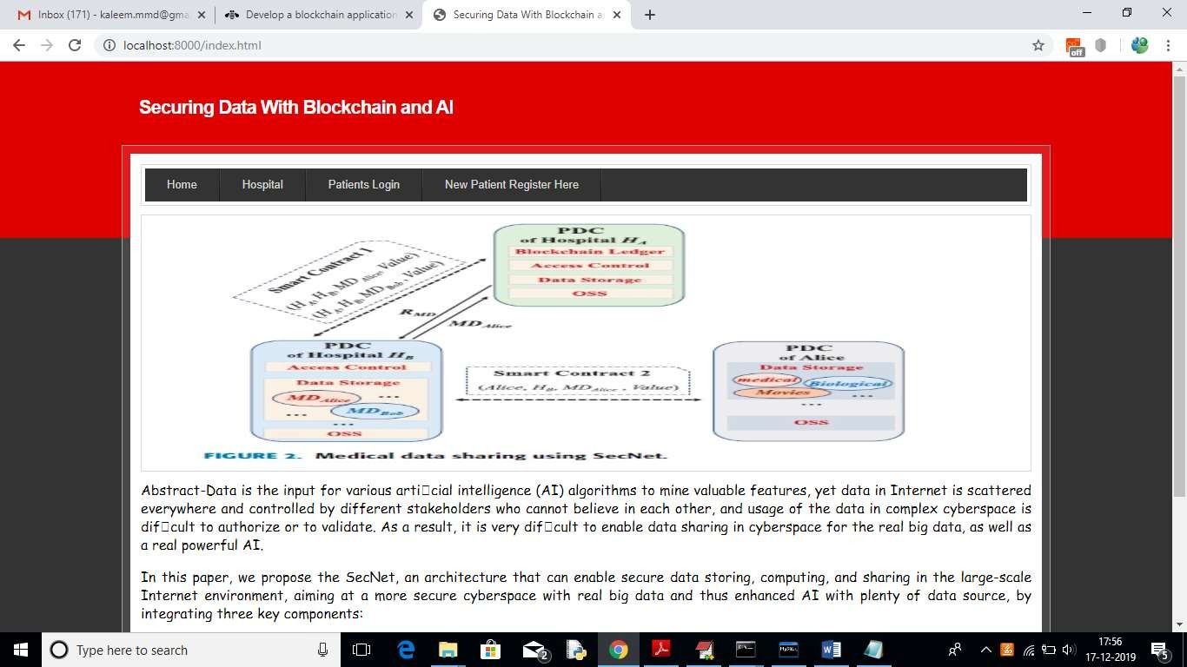
Deploy code on DJANOGO and start server and run-in browser to get below screen

Fig 7.1 index page
In above screen click on ‘New Patient Register Here’ link to get below screen
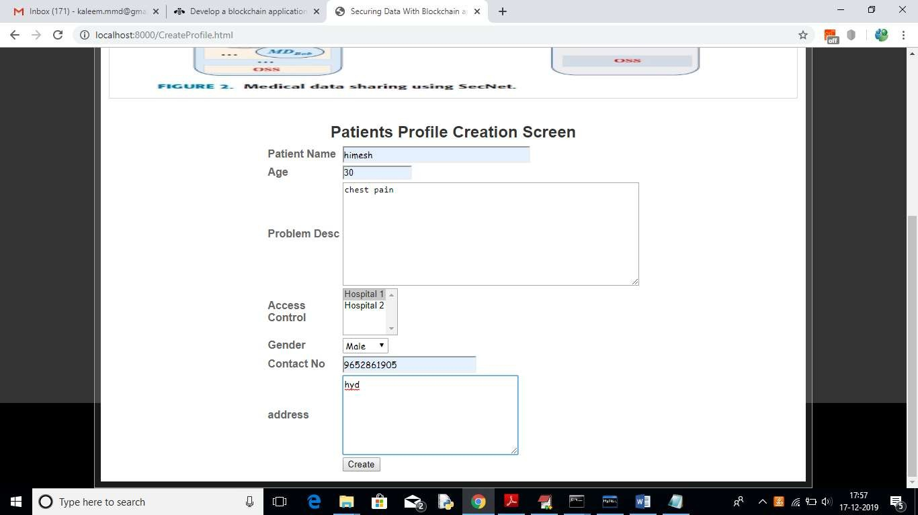

Fig 7.2 Patient New Registration

In above screen I am adding patient disease details and selecting ‘Hospital1’ to share my data and if you want to share with two hospitals then hold ‘CTRL’ key and select both hospitals to give permission. Now press ‘Create’ button to create profile.

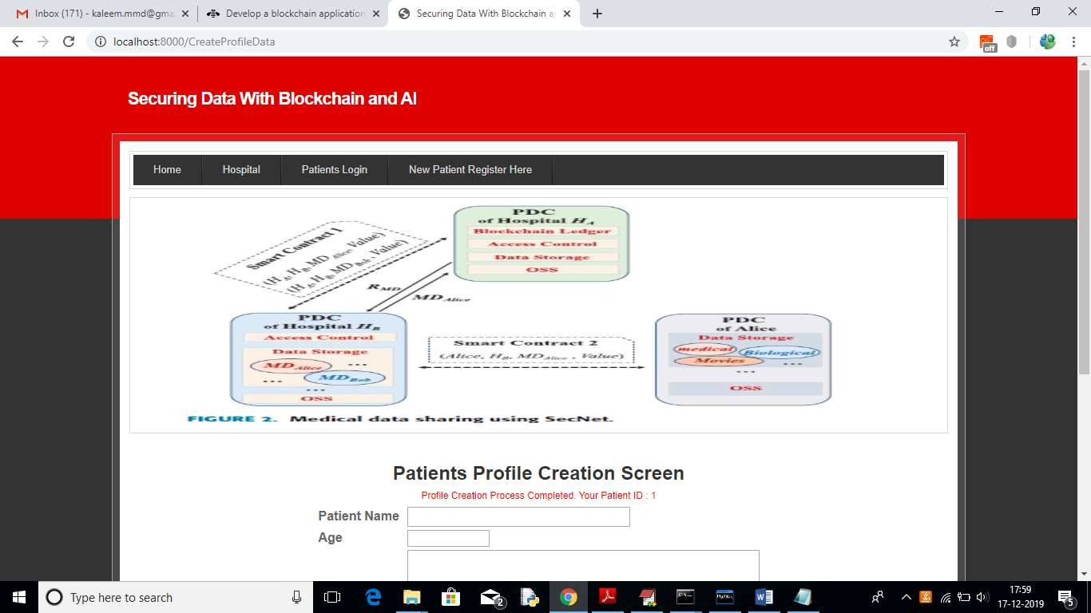
Fig 7.3 Patient profile creation
In above screen one patient is created with patient ID 1 and now Hospital 1 can login and search and access this patient data as patient has given permission to Hospital1

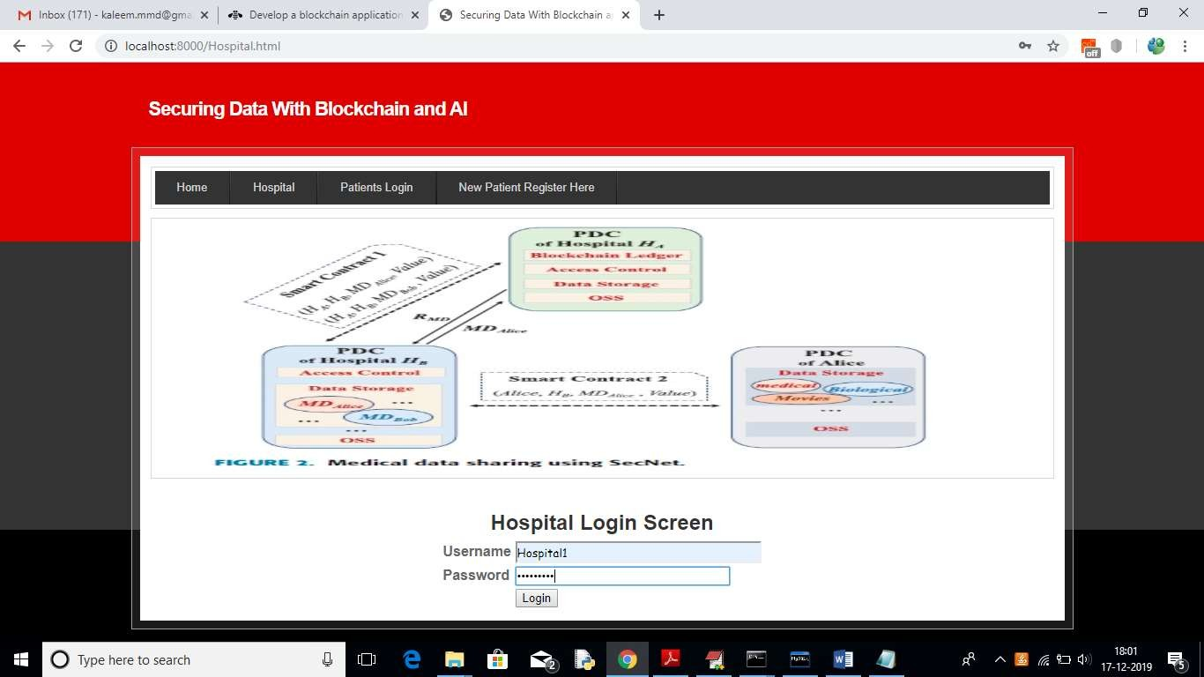

Fig 7.4 Hospital1 login
In above screen to login as Hospital1 click on ‘Hospital’ link to get above screen. Use ‘Hospital1’ as username and ‘Hospital1’ as password to login as Hospital1 and use Hospital2 to login as Hospital2. After login will get below screen
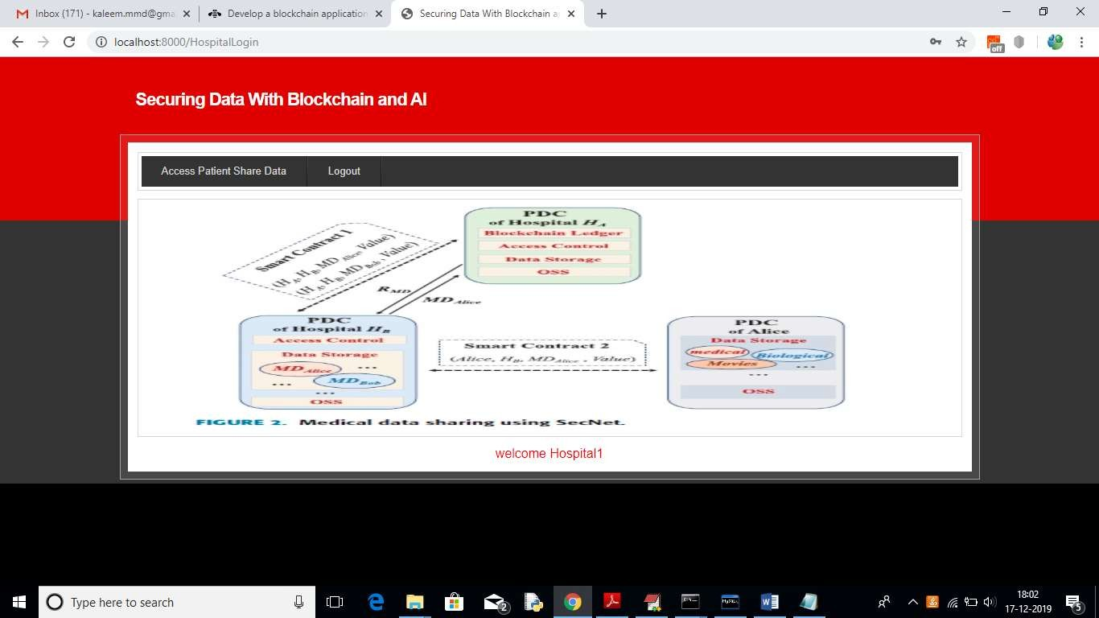

Fig 7.5 Hospital1 welcome page
In above screen click on ‘Access Patient Share Data’ link to search for patient details

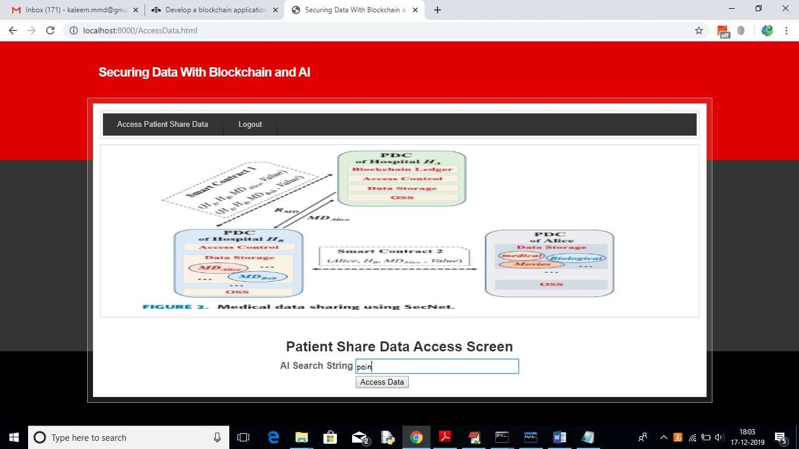

Fig 7.6 Access Patient share Data
In above screen I want to search for all patients who are suffering from ‘pain’ and then click on ‘Access data’ button to get below screen
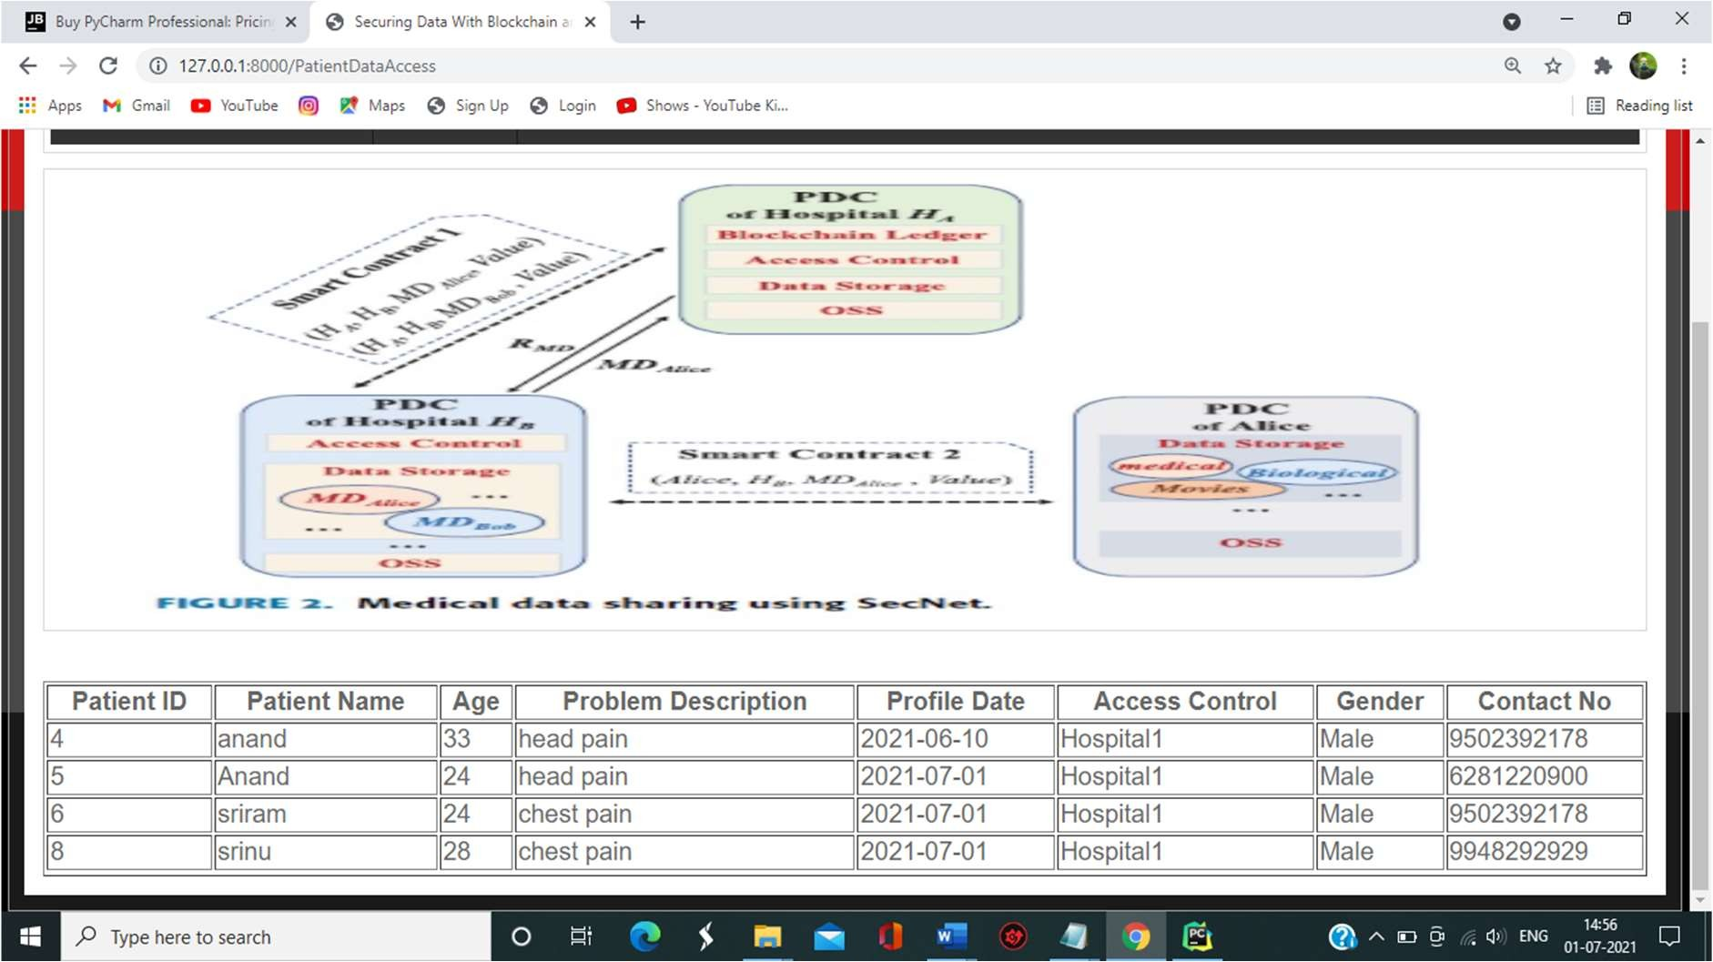

Fig 7.7 Patient Data Access
In above screen Hospital1 is getting details of patient and Hospital2 for not having permission so it will not get details. To see this logout and login as ‘Hospital2’

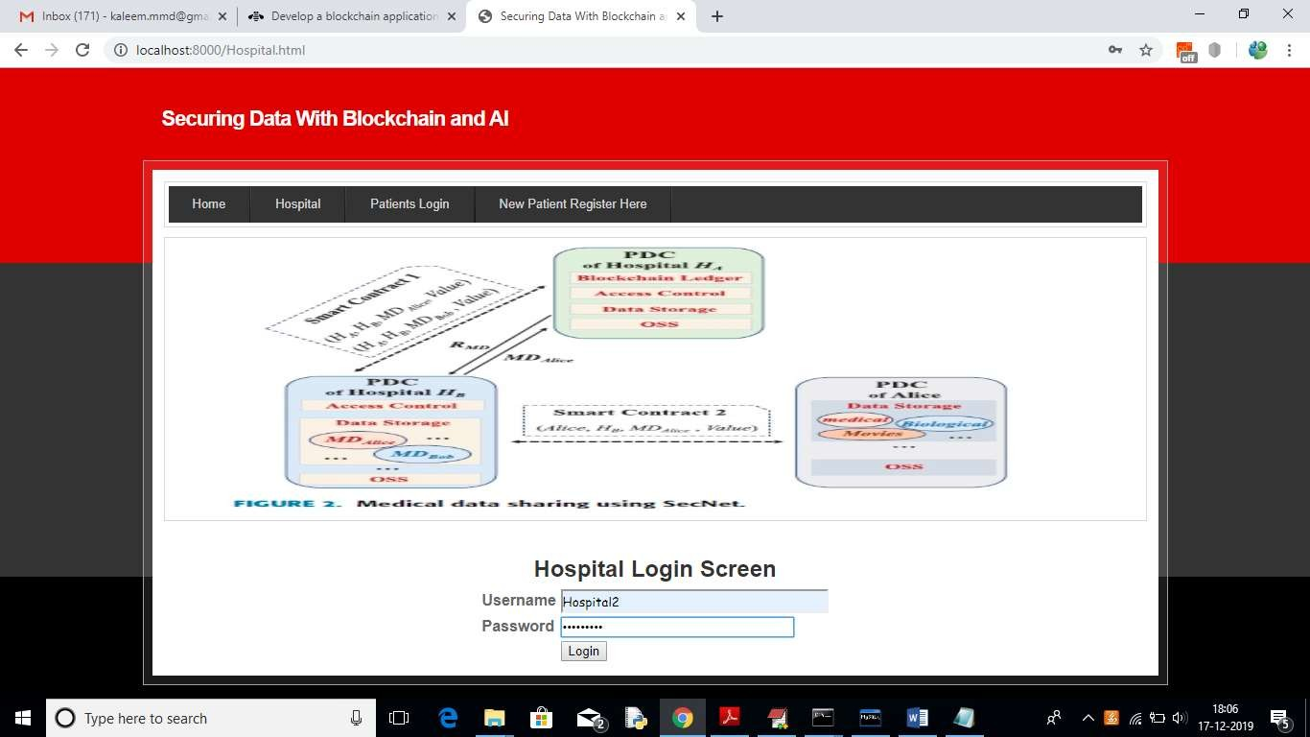

Fig 7.8 Hospital 2 Login
In above screen ‘Hospital2’ is login, after login will get below screen

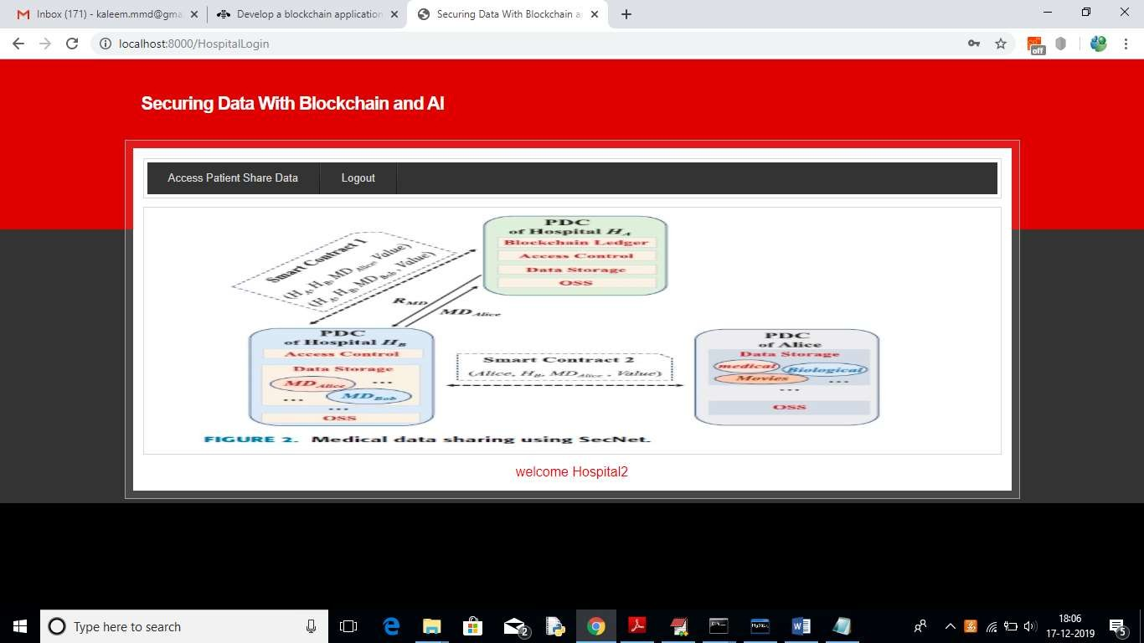

Fig 7.9 Hospital2 welcome
Now click on ‘Access Patient Share Data’ link and search for same pain disease

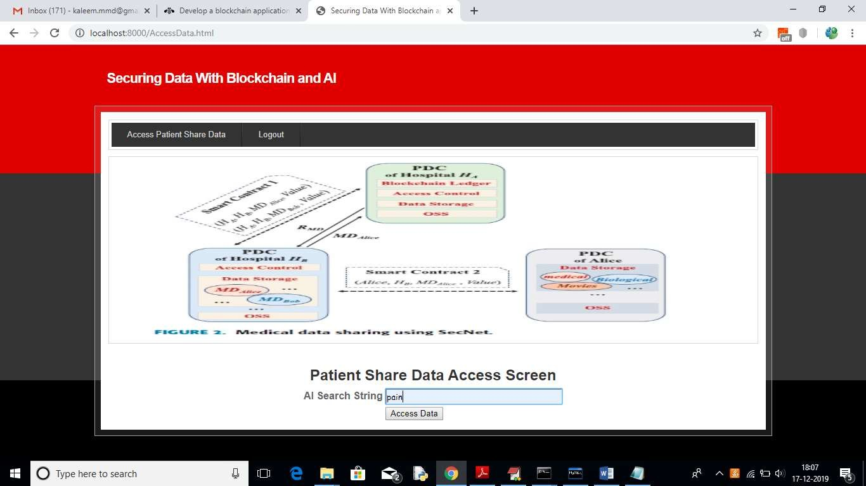

Fig 7.10 Access Patient data
For above query will get below result

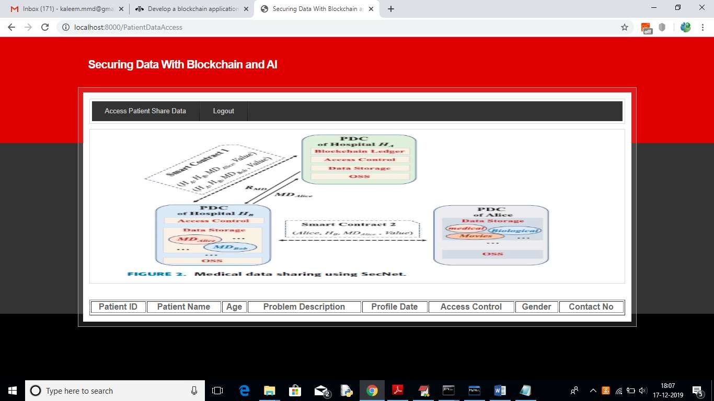

Fig 7.11 Access Data
In above screen no patient details are showing as Hospital2 not having permission. So, block chain allows only those users to access data who has permission. Now logout and login as patient by entering patient id in below screen

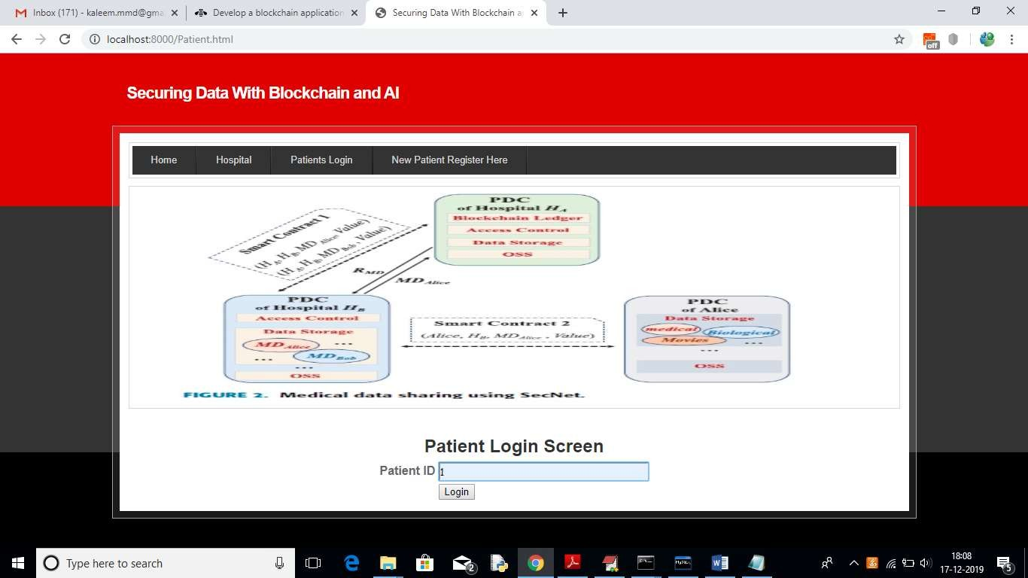

Fig 7.12 Patient login
After login will get below details for patient 1

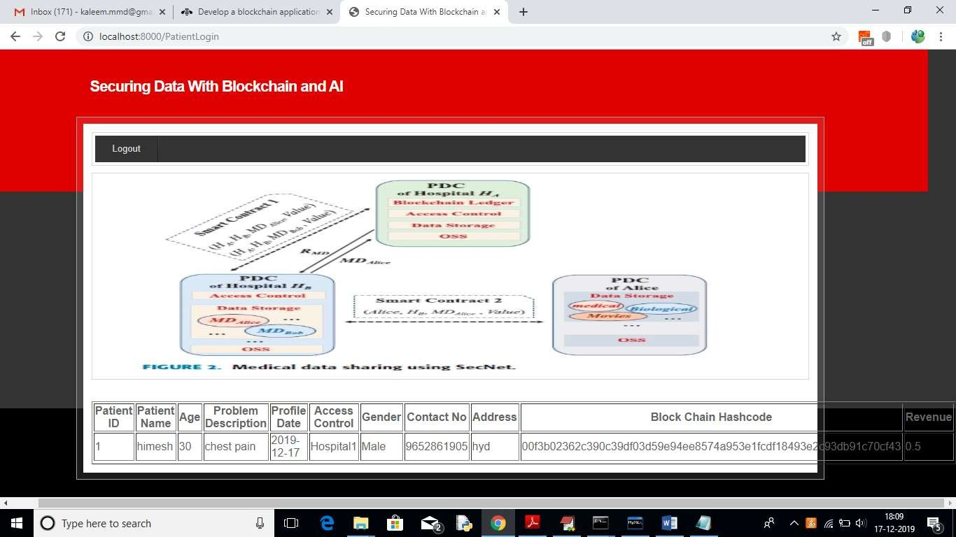

Fig 7.13 Patient ID1 Data
In above screen we can see patient all details and hash code generated by block chain and in last column we can see patient reward revenue as 0.5 and it will get update upon every access from hospital user.

Chapter 8
Conclusion

Conclusion
In order to leverage AI and blockchain to fit the problem of abusing data, as well as empower AI with the help of blockchain for trusted data management in trust-less environment we propose the SecNet, which is a new network paradigm focusing on secure data storing, sharing and computing instead of communicating. SecNet provides data ownership guaranteeing with the help of blockchain technologies, and AI-based secure computing platform as well as blockchain-based incentive mechanism, offering paradigm and incentives for data merging and more powerful AI to finally achieve better network security.
Moreover, we discuss the typical use scenario of SecNet in medical care system, and gives alternative ways for employing the storage function of SecNet. We can see patient all details and hash code generated by block chain and in last column we can see patient reward revenue as 0.5 and it will get update upon every access from hospital user.

Chapter 9
References

References
[1] https://www.python.org/downloads/

[2] https://www.jetbrains.com/pycharm/

[3] https://www.djangoproject.com/

[4] https://www.tutorialspoint.com/python_blockchain/index.htm

[5] https://www.tutorialspoint.com/artificial_intelligence_with_python/artificial_intelligence
_with_python_heuristic_search.htm

[6] https://www.w3schools.com/MySQL/default.asp

[7] https://pynative.com/python-mysql-database-connection/

[8] https://www.javatpoint.com/blockchain-hash-function

